Exercise 1:Ranking and Window Functions

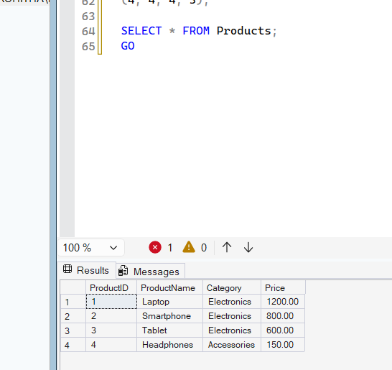

USE OnlineRetailStore;
GO
SELECT
ProductID,
ProductName,
Category,
Price,
ROW_NUMBER() OVER
(
PARTITION BY Category
ORDER BY Price DESC
) AS RowNumber
FROM Products;
SELECT
ProductID,
ProductName,
Category,
Price,
RANK() OVER
(
PARTITION BY Category
ORDER BY Price DESC
) AS RankNumber
FROM Products;
SELECT
ProductID,
ProductName,
Category,
Price,
DENSE_RANK() OVER
(
PARTITION BY Category
ORDER BY Price DESC
) AS DenseRank
FROM Products;
SELECT *
FROM
(
SELECT
ProductID,
ProductName,
Category,
Price,
ROW_NUMBER() OVER
(
PARTITION BY Category
ORDER BY Price DESC
) AS RowNo
FROM Products
) AS T
WHERE RowNo <= 3;
GO
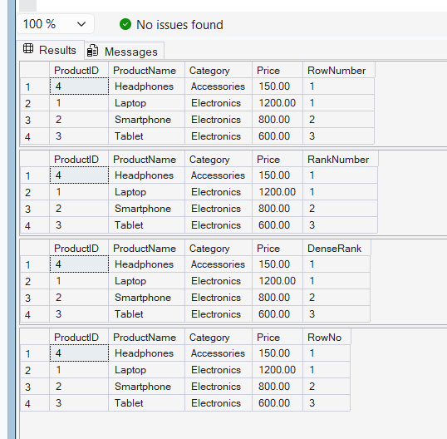

Exercise 2: Index

